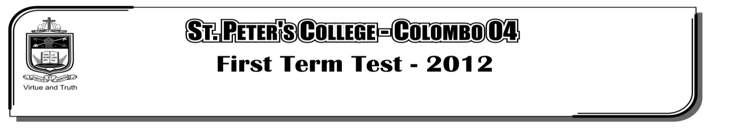

**THIRD TERM EXAMINATION - 2020**

**GRADE 11 – MATHEMATICS I**

**2 Hours**

**Part - A**

**Answer all the questions.**

01. Find the value 2-1 + 3-1

02. If , Find the value of $\frac{20}{\sqrt{2}}$ to the first decimal place.

y

x

B

A

(-2,0)

03. If gradient of the straight **AB** is 2. Find the equation of **AB** straight line.

04. If lg 5 = 0.6990 , Find the value of lg 20

D

C

B

E

A

05. Area of triangle BCE is 30 cm2. Find the area of the ABCD trapezium.

y

C

A

x

40

B

O

06. O is the centre of the circle. Find the value of x and y.

07. (x2 - 4) , (x +2) , (x - 2) Find the L.C.M. of given terms.

08. Make x the subject of the formula ax = bx + C

O

C

A

D

B

09. Centre of the circle is O and AB is a cord. D is mid point of AB. AB = 10 cm and OD = 5 cm. Find the length of AC.

10. The first three terms of a geometric progression are respectively 4 , *x* , 100. Find two values for *x*.

11. Order of the matrix A is (4 x 2) Order of the matrix B is (2 x 1) Write the order of the matrix AB.

50

60o

x

D

C

A

B

E

12. According to the data. Find the value of x

$ε$ 50

40

15

5

A

B

13. In Venn diagram represents numbers of elements. Find

14. Simplify (3x - 2)3

15. In a cricket match winning probability of a team is Four times of not winning probability. Find the winning probability of the team.

b

40o

a

60o

C

Y

D

O

X

A

B

M

16. AB and CD are two tangent with point of contacts are X and Y respectively. Find the value of a and b.

17. 11 – 30

31 – 50 considering the class intervals above. Find the size

51 – 70 of class interval 31 – 50.

6

12

x

3x-1

18. In the figure BC // CD. Using data Find the value of x.

A

B

C

19. ABC is a Isosceles Right angle triangle. AB = BC. Find the value of tan 45o.

20. Probability of event A is P (A). If P (A) = $\frac{2}{3}$ write the value of P (A1).

*x*

A

B

C

D

E

F

21. ABCDEF is a regular hexagon. Find the value of *x.*

m

4m

2m

22. Above cuboid shape tank length breath and height are 4m , 2m and $\frac{3}{2}$ m respectively. Find the capacity of the tank in liters.

X

Z

Y

P

Q

R

23. In the triangle PQR incircle is drawn in the figure. PX = 6 cm QY = 5 cm ZR = 4 cm. Find the perimeter of the triangle PQR.

24. Total surface area of a cuboid is 220 cm2. Find the suitable three values what numbers for length breath and height

A

B

C

25. Find the centre of the circle which touches AB at B and passes through the point C (rough sketch). Mark centre as O.